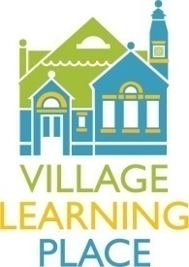
LINK Reading Intervention Volunteer

The Village Learning Place, at 2521 St. Paul Street, is an independent non-profit library that houses educational programs, enrichment opportunities, and informational resources for Charles Village and throughout Baltimore City. The VLP is a library that is not only a repository for books, but is also a community center focused on the personal and professional growth of its patrons.

Job Title: LINK (Let’s Invest in Neighborhood Kids) Reading Helper

Brief Job Description: LINK Reading Helpers work with the Reading Intervention Teacher to support our lowest and highest readers in the program. LINK Reading Helpers work one-on-one and with small groups of students to help strengthen reading skills and provide reading enrichment opportunities for students who are reading well above grade level.

Qualifications: LINK Reading Helpers must have strong literacy skills, and a desire to work with at-risk youth.

Time Commitment: LINK Reading Helpers should be prepared to participate in the program a minimum of one day per week.

Benefits: Working with the LINK After School program is rewarding and fun. Our students are hardworking, creative, curious, and social. Making an investment in the lives and academic success of LINK students is priceless.

For more information or to volunteer, please contact:
Our Development Department
vlpnews@villagelearningplace.org

