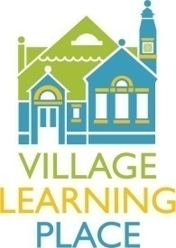
Special Events/Programs

Job Title: Special Events or Programs Volunteer
Brief Job Description: Several times throughout the year, the VLP hosts special events and programs. Volunteers will work to ensure that the event or program runs smoothly and successfully.
- Spaghetti Disco – Saturday, March 5, 2016
- Read Between the Wines – Saturday, April 30, 2016
Responsibilities might include:
- Set-up: helping to set up the day before and/or of the event
- Clean-up: helping to clean up after the event
- Door/ticket sales: greeting guests, ticket sales (if applicable)
- Food: serving food (if applicable)
- Floaters: a number of floating volunteers will be needed to help with things like trash/recycling, general event questions, logistics, etc.
- Other: other tasks as assigned
Qualifications: Volunteers should be accountable, enthusiastic, and dedicated to helping make an event or program a success.
Time Commitment: Dependent upon event. Event/program volunteer shifts are often 1-2 hours.
Benefits: Events can be an incredibly fun volunteer opportunity! Volunteers may enjoy the opportunity to meet and greet familiar and new friends and neighbors while contributing to an event in support of our community or the VLP. Often, if there is event admission, it is waived for volunteers.
For more information or to volunteer, please contact:
Our Development Department
vlpnews@villagelearningplace.org

